Teraform S3 bucket and Ec2 instance

Here I am install terraform and aws cli in my laptop

After installing terraform and aws cli in your laptop check versions using cmd or git bash or powershell

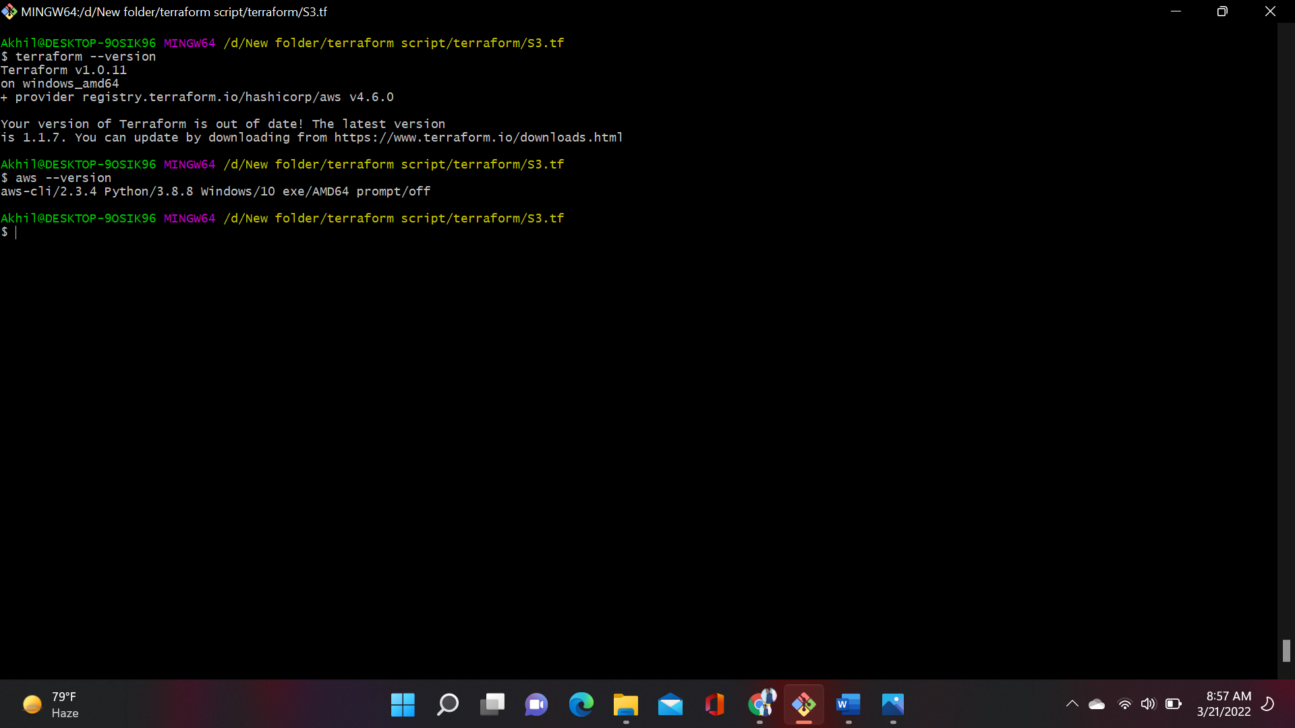

First open git bash and configure aws using the command aws configure

It will ask you access and secret key provid them

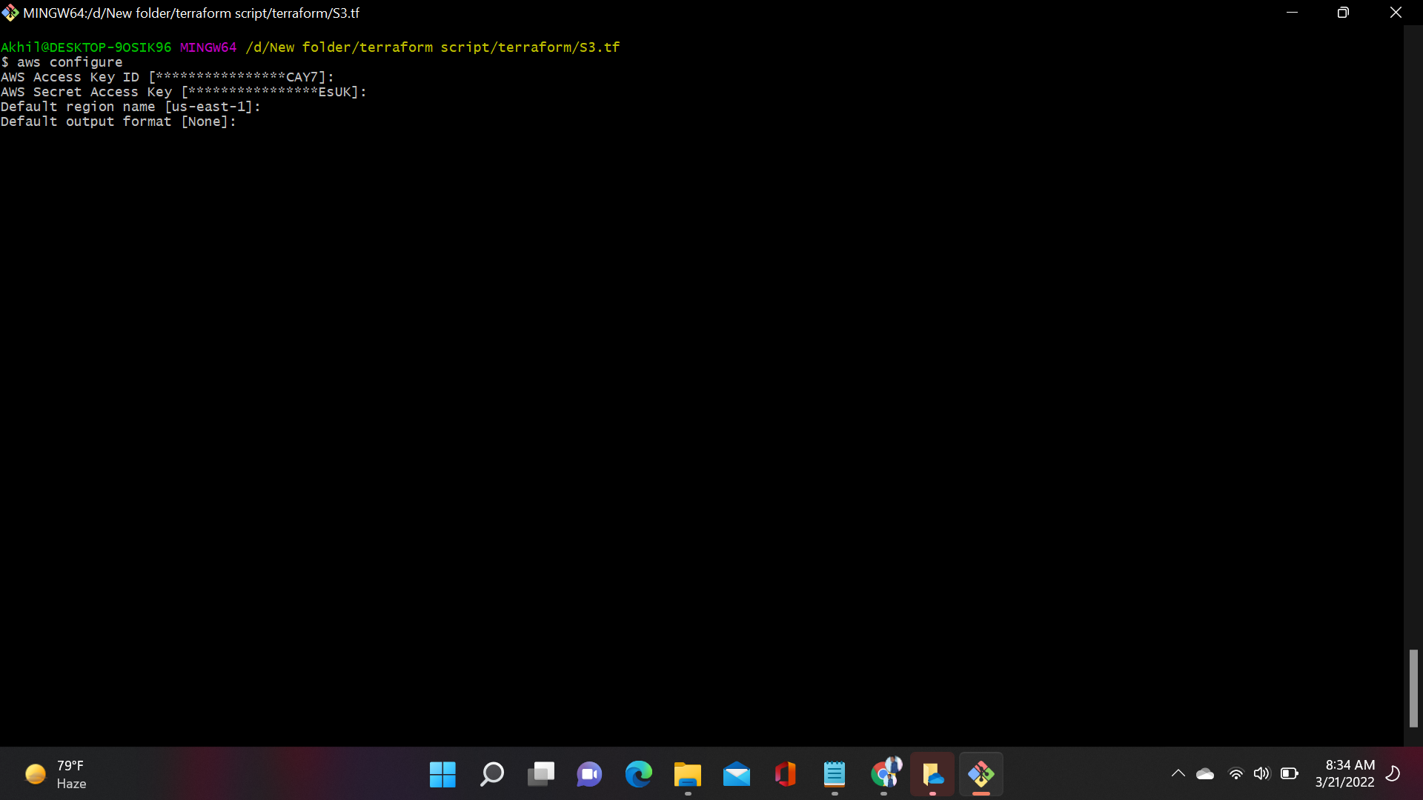

This is terraform Script to create infrastructure (Ec2 instance and S3 bucket)

Create a file using Vi S3.tf enter the script in that terraform file

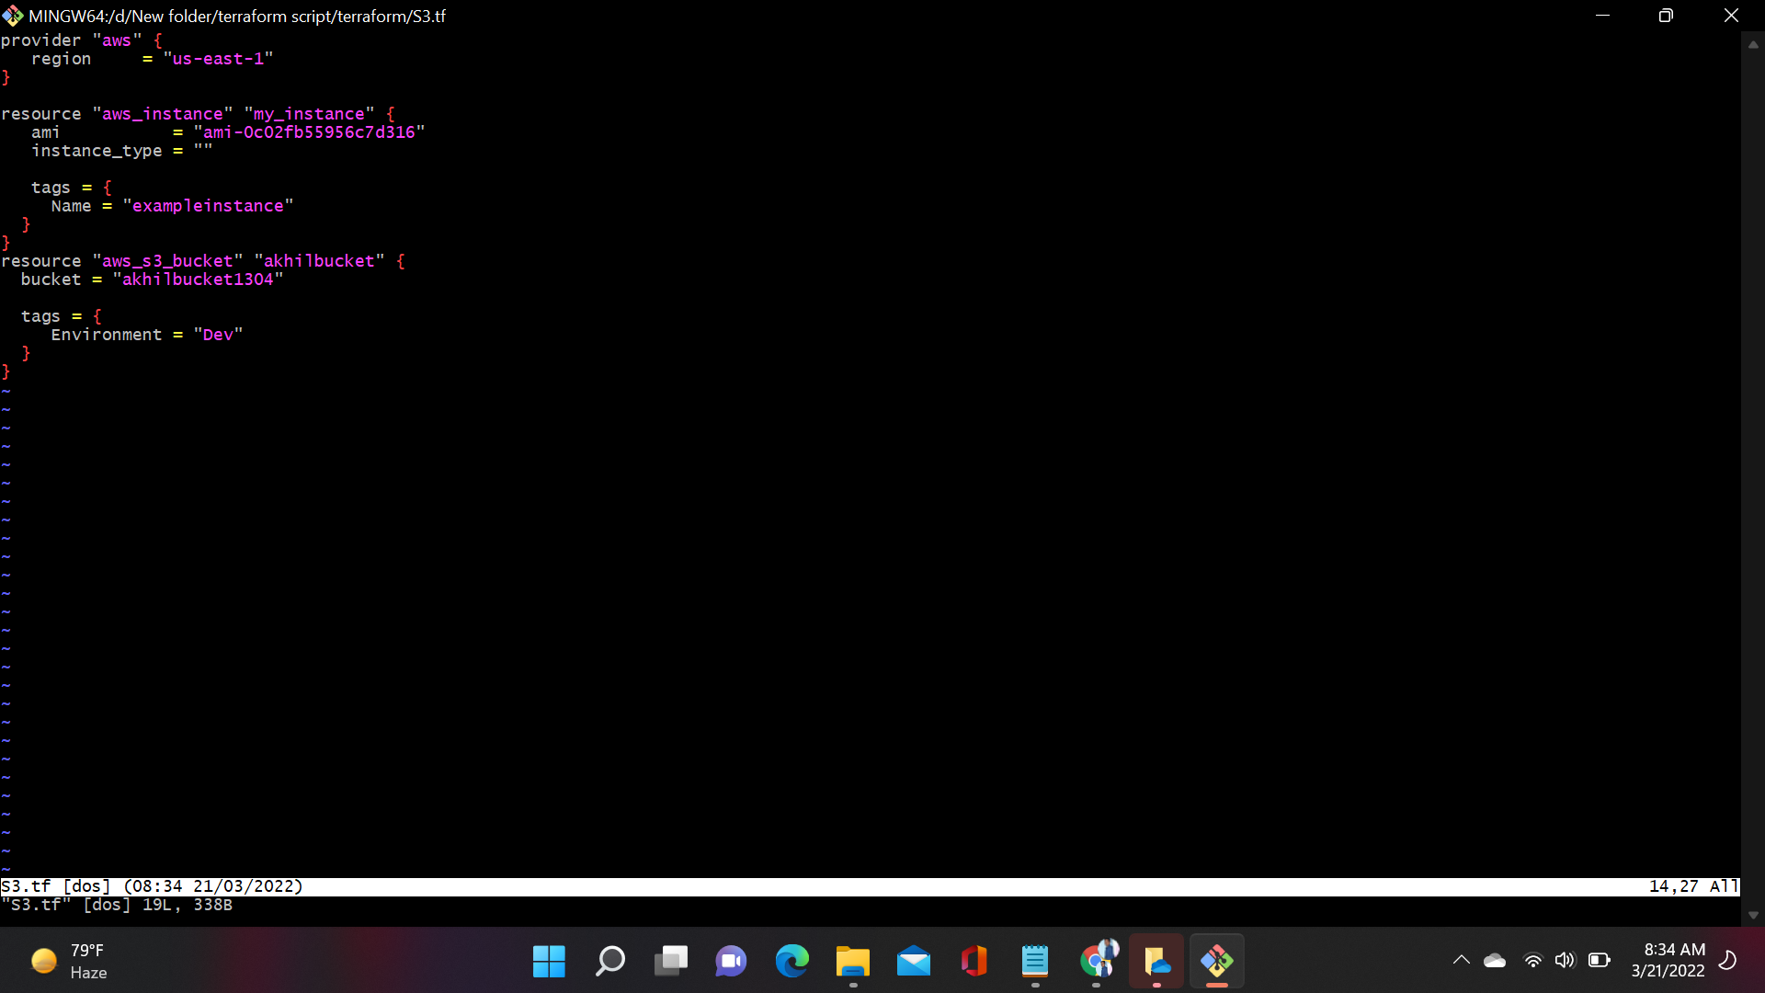

Terraform Init: - Initialize the current directory

Step 1 terraform init

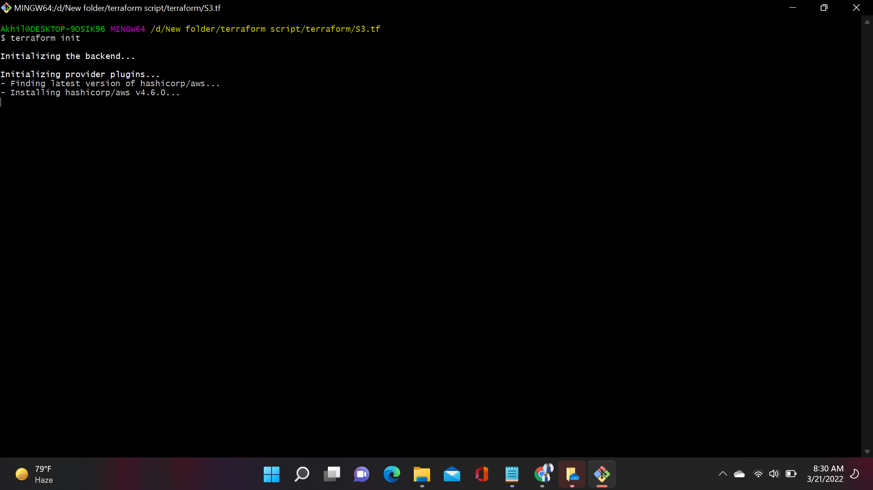

Terraform Plan: - Dry run to see what terraform will do

After successful initialization then enter terraform plan

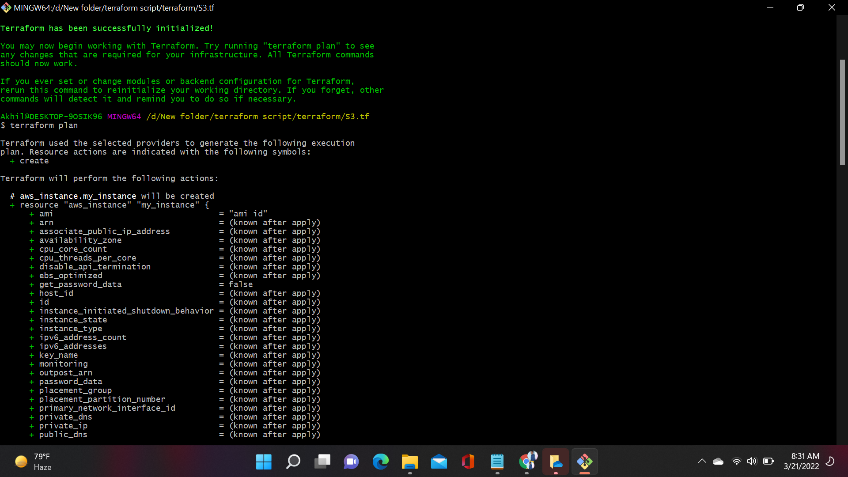

After that enter terraform plan

Terraform Apply:- apply the Terraform Code

After entering the command terraform apply the infrastructure will be created

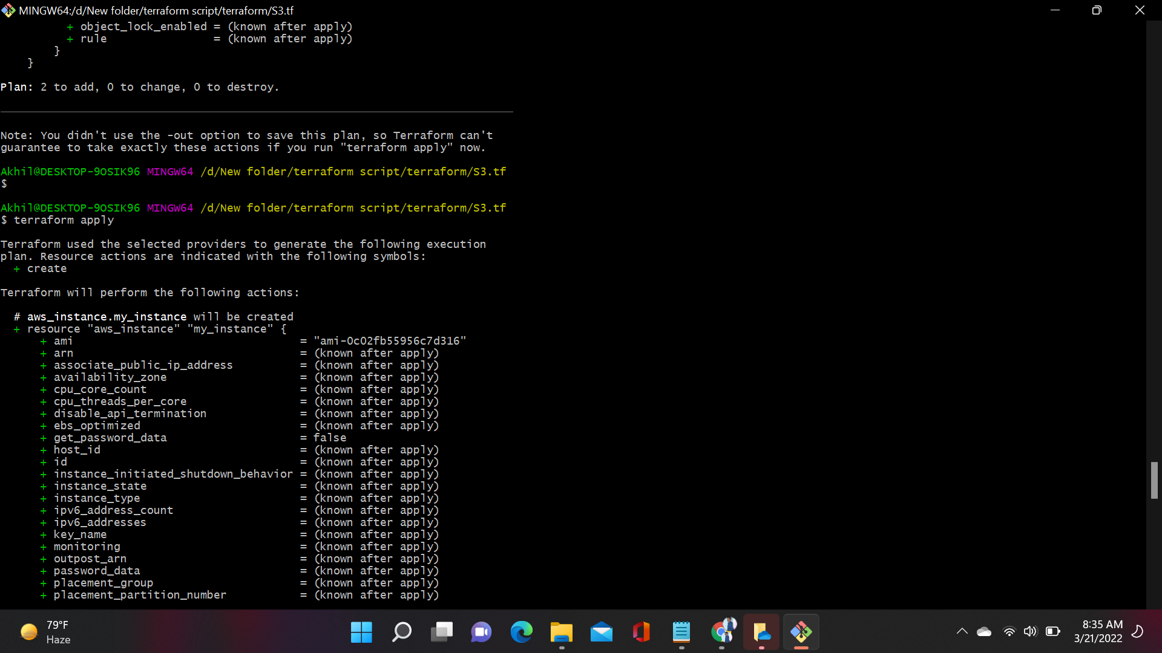

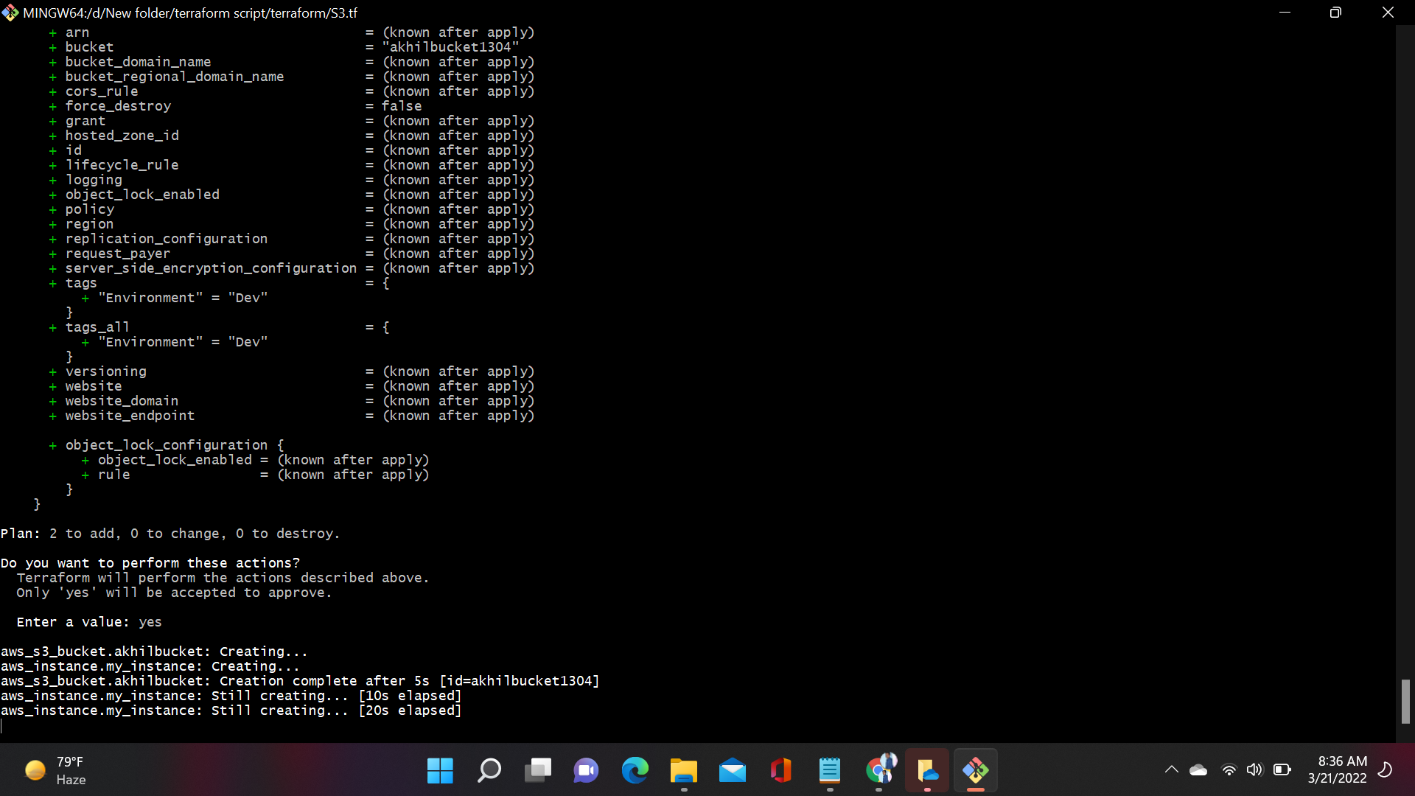

After using the terraform apply one instance have been created

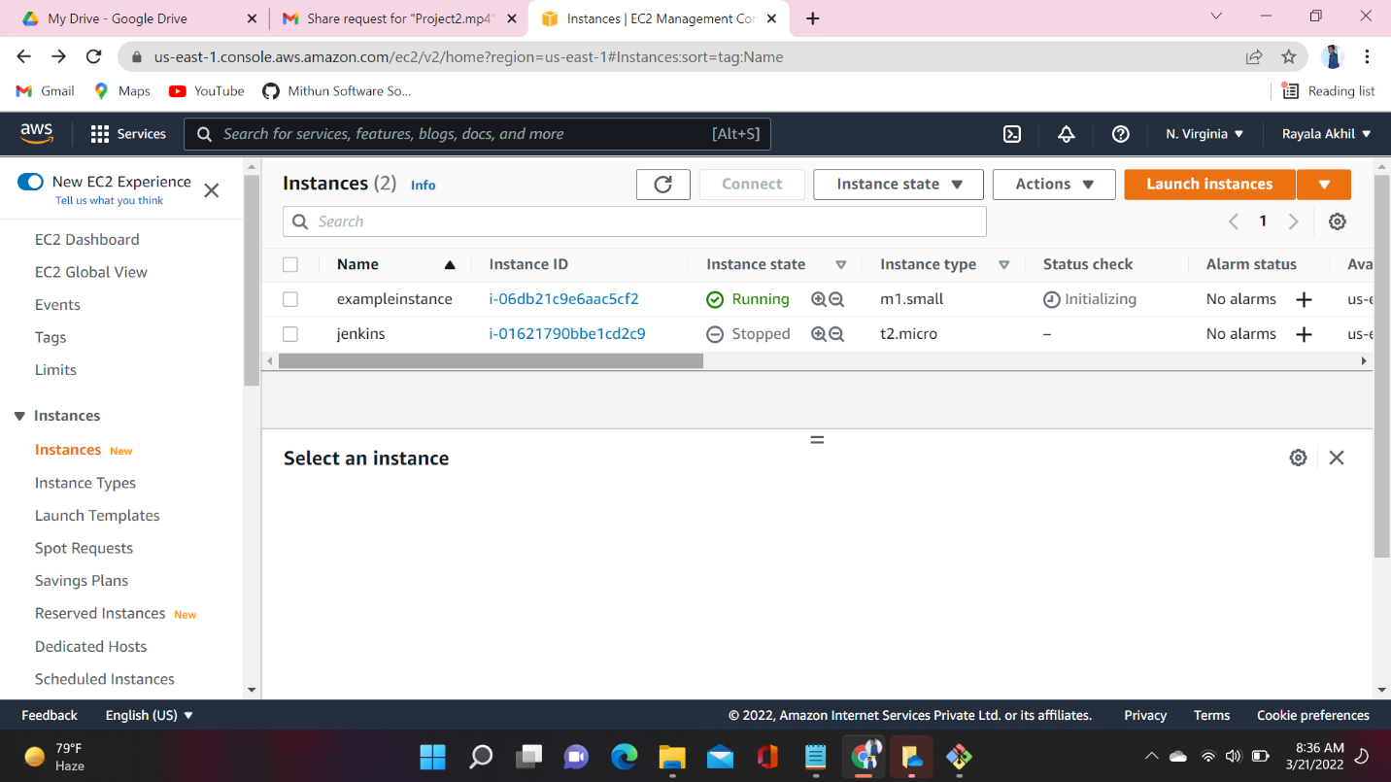

Along with one instance S3 bucket also created. In S3.tf file we have the terraform Script for both instance and the S3 bucket

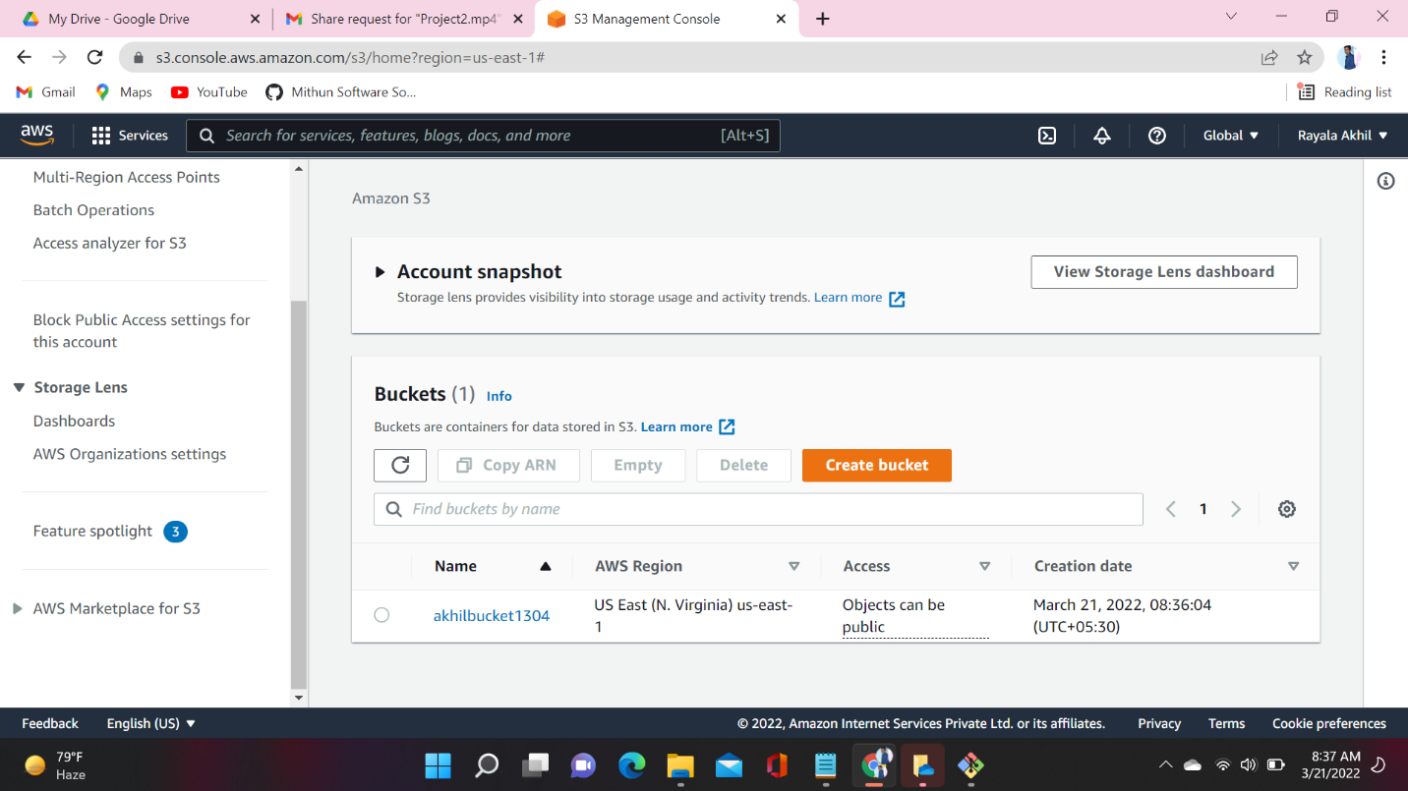

Terraform Destroy: - Destroy what was built by Terraform

After succeful creating of infrastructure I want to destroy that infrastructure using destroy command

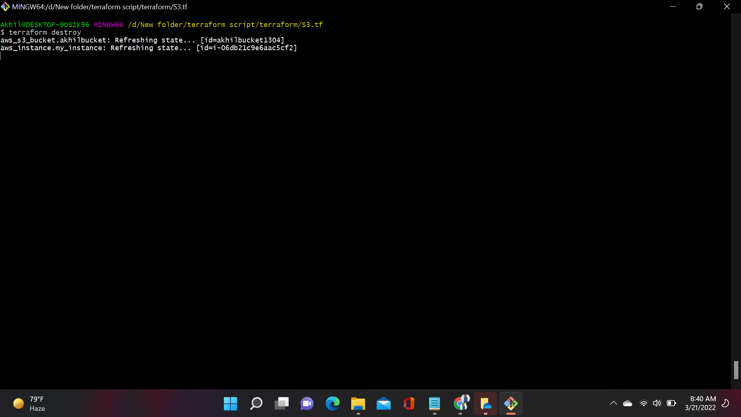

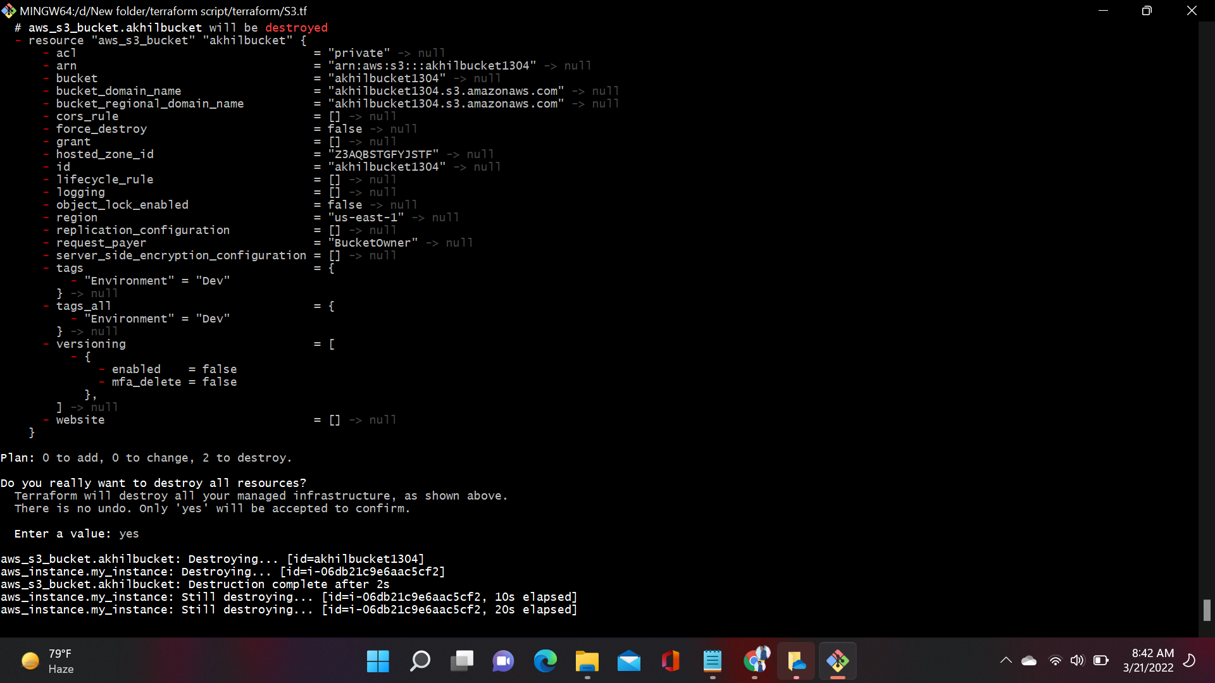

See below images earlier I have instance which I was created but now it was not there

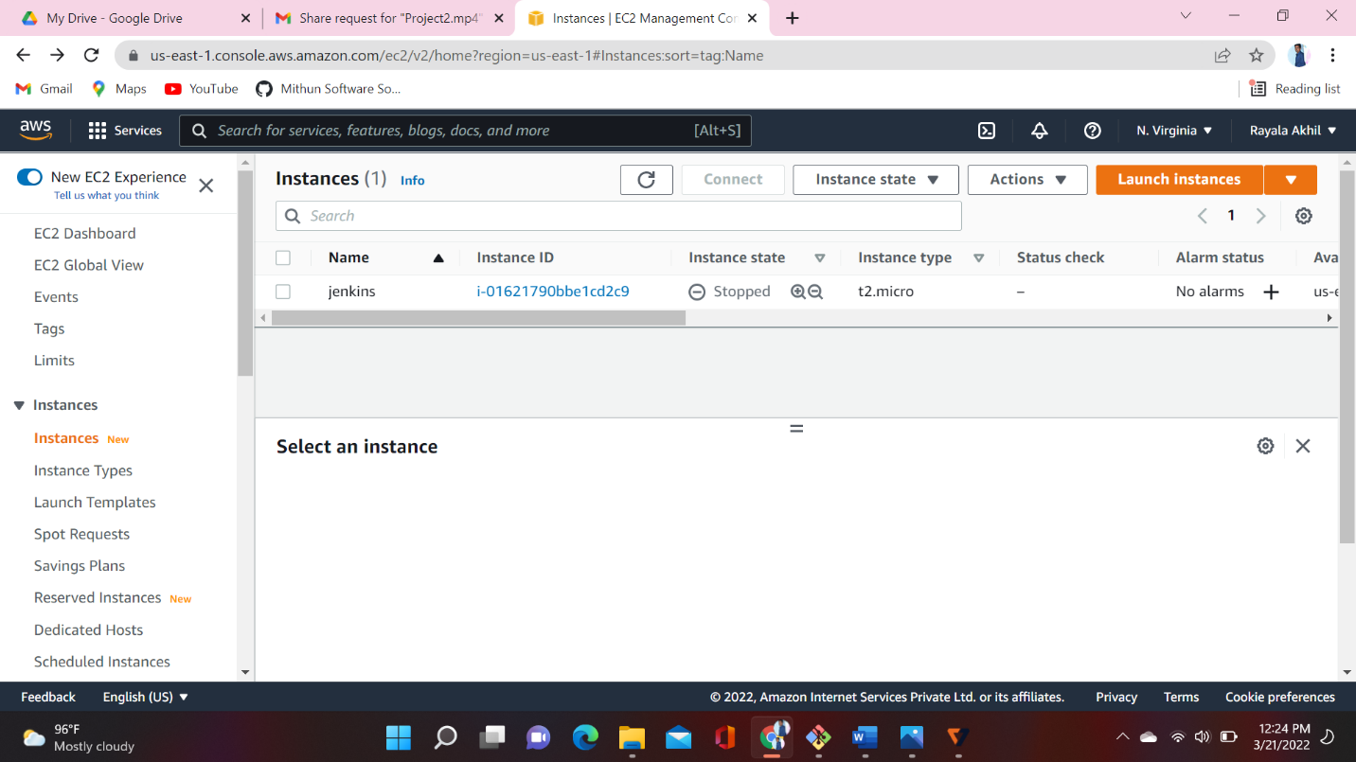

Earlier I have one S3 bucket at present I don’t have any S3 bucket

